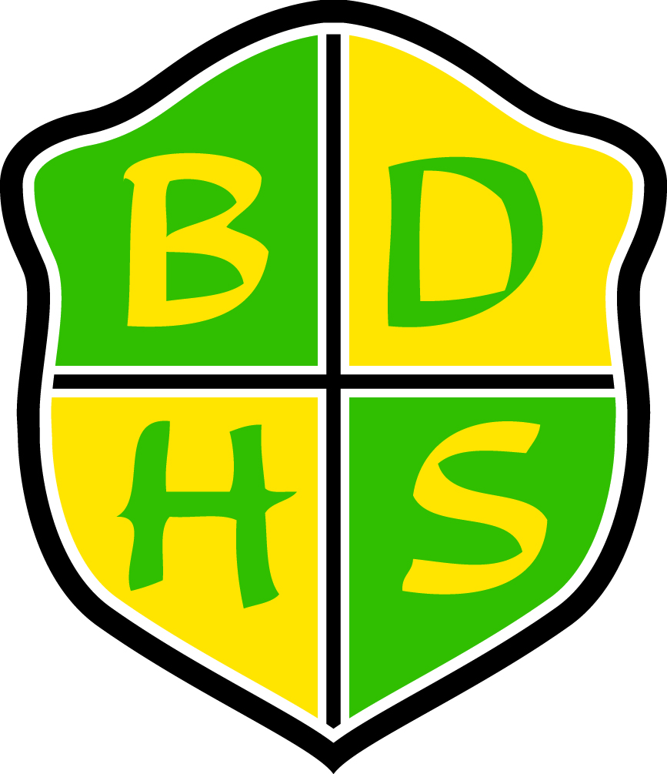
Beaver Dam High School Syllabus
Department: Special Education  School Year: 2011-2012  Course: Language Skills 11/12  Grade Level: 11/12  Required Materials: Notebook, Folder(s), Writing Utensil(s) |  |  | Course Resources: Language Arts Warm Ups(Cavazos, 2006); Vocabulary and Workplace Career Words (Quinley, 2010); Adolescent Career Development (2005, del Valle, Werner, Rodriguez); The 21st Century Coach: Succeeding in the Workplace and in Life (2011, Saddleback Publishing); Daily Paragraph Editing (2004, Evan-Moor); Tribes Learning Communities (Gibbs, 2006); English for the World of Work (2006, AGS); Challenger Adult Reading Series, (Murphy, New Readers Press)  Prerequisites: None
Course Description: Click here to enter text.
Language Skills 11
The development of employment, as well as English skills is the emphasis of this course. Job-hunting skills, resume writing, job application skills, IEP development, interviewing skills and job retention skills are components of the curriculum. Students will also read and discuss novels and work on developing their reading and writing skills. Students will also engage in developing cooperative learning, working, and problem-solving skills throughout the course.

Language Skills 12
A continuation of Life Skills 11and portfolio completion.

Units Covered (but not limited to): Understanding Oneself/Learning/Working styles, Problem-solving, Job Applications, Resume’ Writing, Communication in the Workplace, Interviewing skills, Self-Determination/Self Advocacy, Portfolio development, Language skill development (Reading, Writing, Spelling), Employer Expectations, Workplace Competencies, Job Evaluations, Maintaining Employment, Getting Along with Co-workers, Workplace Safety, Completing Forms, Goal Setting.

Summative Assessments:  - Quizzes- Weekly assessments  - Tests/Projects |  |  | Formative Assessments:  - Daily work- Journals, work-book, small group and whole group lessons and community development.
Courses at BDHS run in a flexible schedule format. See selection to right for this course’s format: | One-Term 90 ☐ | Two-Term 90 ☐ |  | All-Year 45 X | Other ☐
School-wide Grading Procedures:

Assessments 85%
- Formative 30% (of assessment grade)
- Summative 70% (of assessment grade)
Cumulative Final 15%

Summative Assessments: (this shall constitute 70% of the term grade)
Our goal is to assess what the students have learned from what we have taught. Summative assessments reflect the format and content of the formative learning opportunities.

Make-up Policy for Summative Assessment: The student may redo the summative assessment one time within one week after completing all formative tasks, and necessary additional learning. It is the student’s responsibility to advocate for this opportunity and make the necessary arrangements.

Cumulative Final: At the end of the semester, there will be a cumulative final exam. Students will not be allowed to retake this assessment. This will comprise 15% of the semester grade.
School-wide Grading Scale: |  |  | Contact Information:  Teacher Name: Kathy Hoefler  Teacher Email: hoeflerk@bdusd.org  Teacher Phone: 885-7520 Ext 2126 or Ext. 2248 (vm)  Beaver Dam High School  500 Gould St.  Beaver Dam, WI 53916  www.beaverdam.k12.wi.us  (920)885-7520
  A+ | 98-100 | C+ | 77-79
  A | 93-97 | C | 73-76
  A- | 90-92 | C- | 70-72
  B+ | 87-89 | D+ | 67-69
  B | 83-86 | D | 63-66
  B- | 80-82 | D- | 60-62

